# DECLARATION

I, Jerome MUSENGIMANA, hereby declare that this project is my own work and it has not been published and not presented at any higher leaning institution.

Student Supervisor

MUSENGIMANA Jerome Mr.NIYODUSENGA Peter

Signature: …………….. Signature:.……………. Date……/….../………

Date ……/……/……….

# APPROVAL

This is to certify that this project report has been submitted to Adventist University of Central

Africa (AUCA) has been under my supervisor and proposal report is now ready for submission to the university council with the approval of my supervisor as a partial requirement for the award of Bachelor degree in Information Technology.

Approved by Supervisor: Approved by Head of department:

.......................................................................................................

Signature:………………….... Signature:…………………..........

Date:........../........../.......... Date:........../........../..........

# DEDICATION

I dedicate this work to my parents for their support during all the time of my studies. I also dedicate it to all my friends, especially Student at AUCA without forgettingalso my supervisor for his guidance.

**TABLE OF CONTENTS**

DECLARATION i

APPROVAL ii

DEDICATION iii

FIGURES vii

TABLES ix

LIST OFABBREVIATION x

ACKNOWLEDGMENT xi

CHAPTER 1 1

GENERAL INTRODUCTION 1

Background of the Study 1

Problem of the Statement 3

Choice and Motivation in the work 4

Objectives 5

General objective 5

Specific objectives 5

Challenges 5

Scope of the Study 6

Expected Results 6

Subdivision of the work 6

CHAPTER 2 8

ANALYSIS OF THE EXISTING SYSTEM 8

Definitions of terms 8

Methodology and techniques of problem solving 10

Requirements collection techniques 10

The documentation 10

The interview 10

The observation 10

Analysis of the existing system 11

Introduction 11

Proposed Solution to the Problem Found 12

CHAPTER 3 14

REQUIREMENTS ANALYSIS AND DESIGN OF THE NEW SYSTEM 14

Introduction 14

Unified Modeling Language (UML) 14

Object-oriented systems 15

Software development process 15

Unified Process (UP) 15

Phases of UP 15

Inception Phase 15

Elaboration Phase 16

Construction Phase 16

Transition Phase 16

Conception and notation 17

Analysis of the new system 19

Domain Analysis 29

Design of new system 34

Sequence Diagram for Send Request 37

Sequence diagram for Accept request 38

Sequence Diagram for Searching Records 39

Sequence Diagram for View Record 39

Sequence Diagram for Update Records 40

Sequence Diagram for Viewing Report 40

Database Design 41

Notations and their usage 41

CHAPTER 4 44

IMPLEMENTATION AND TESTING OF THE NEW SYSTEM 44

Introduction 44

Technologies Used for the System Implementation 44

Cascading style sheets 45

JSP Technology 46

Software Tests of OGMSMS 47

Unit software testing 48

Integration Testing 49

Validation or Acceptance Testing 49

CHAPTER 5 62

CONCLUSION AND RECOMMANDATION 62

Conclusion 62

Recommendation 63

REFERENCES 64

APPENDICES 67

# FIGURES

Figure 1: Organization structure of cnlg 9

Figure 2: CNLG use case diagram 23

Figure 3 : Class diagram 30

Figure 4 : System architecture diagram 35

Figure 5 : Sequence diagram for login to the system 37

Figure 6 : Sequence Diagram for Send Request 37

Figure 7 : Sequence diagram for Accept request 38

Figure 8 : Sequence Diagram for Record info 38

Figure 9 : Sequence Diagram for Searching Records 39

Figure 10 : Sequence Diagram for View Record 39

Figure 11 :Sequence Diagram for Update Records 40

Figure 12 : Sequence Diagram for Viewing Report 40

Figure 13 : Sequence Diagram for creating new site 41

Figure 14 : Database diagram 43

Figure 15 .Loginpage 49

Figure 16 : New users Login page 50

Figure 17 : Victims form 51

Figure 18 : Visitor welcoming page 52

Figure 19 : Visitor Registration form 53

Figure 20 : Suggestion Box form 54

Figure 21 : Grave Registration Form 55

Figure 22 : Form to Add and View Sites 56

Figure 23 : Form to Add and View Employees 57

Figure 24 : Form for making a request 58

Figure 25 : Form to approve request 59

Figure 26 : Grave report form 60

Figure 27 : Sites Memorial Report 60

Figure 28 : Feedback Report for visitor request 61

# TABLES

Table 1 :visitor class description 31

Table 2 : site memo class description 32

Table 3 :grave class description 32

Table 4: employee class description 33

Table 5: victim class description 34

# LIST OFABBREVIATION

AUCA - Adventist University of Central Africa

CNLG **-** National Commission for the fight against genocide

DBMS - Database Management System

GUI - Graphical User Interface

HTML - Hyper Text Mark-up Language

HTTP - Hyper Text Transfer Protocol

IDE - Integrated Development Environment

JSP - Java Server Page

MVC - Model View Controller

ODBC - Open Database Connectivity

OGMSMSR - Online Genocide Memorial Sites Management System for Rwanda

OOA - Object Oriented Analysis

OOD - Object Oriented Design

PK - Primary key

SQL - Structured Query Language

UML - Unified Modeling Language

UP - Unified Process

XML - Extensible Mark-up Language

## ACKNOWLEDGMENT

Above all, I thank almighty God for his grace and mercy during my studies. This work would not have been possible without the support of many people. Therefore, I would like to express my gratitude first to Adventist University of Central Africa’s authority, administrative and academic as well for the support and assistance during our academic period. In a special way, I acknowledge all lecturers without this knowledge and assistance this work would not have been successful.

My gratitude also goes deeply to FARG which has been there for financial support and helped me in all needed education,and sincere thanks to our dear beloved parents who have helped and supported me during my studies to the completion of this work, and all my sisters for their support and encouragement. My sincere thanks to Mr. NIYODUSENGA Peter for his guidance, insight, patience, support and supervision forthis project.

A special mark of honor goes to Permanent Executive Secretary of CNLG DR. Jean Damascene BIZIMANA for giving me the authority to work on this project and I greatly thankto all CNLG Staff for their availability and collaboration during my project.

Finally, I greatly thank my classmates for their support and knowledge sharing during our class time period, all our friends and relatives who, in one way or another, contributed to my academic success.

The Almighty God bless you all.

# CHAPTER 1

## GENERAL INTRODUCTION

Nowdays we live in the "information age," in which information technology has become a part of our everyday lives that has improved and makes work and life a lot easier. Many companies, enterprises or institutions that adopt Information Technology in their daily work, they perform their services faster and efficiently. On the IT market the sale of software increases because most of companies or organizations begin to computerize their services.

## Background of the Study

In nowadays world, we see a lot of crimes done upon human being such as violence, fighting, stealing and killing one another especially during the wars or during the moment of stealing others. Among these crimes we see that they are being done in many countries of America, Europe, Asia and Africa especially the crime of killing the human being that has reached another higher level.

The UN(United Nations) has decided that some countries in which there have been a very powerful and strong crime of killing people that had been prepared by the government regarding the segregation of believes, area(region), sex and race or ethnic groups. This crime has been termed as Genocide.

One of the countries that met this horrible crime and confirmed by the UN the Rwanda is among them in 1994 from April 7 to July 4. Rwanda lost more than one million of people only within three months and the victims were killed because of how they had been created only.

The government of Rwanda decided to build genocide memorial sites to depose the bodies of the 1994 victims. Those genocide memorial sites have been selected as museums in each area and they are built at Murambi, Ntarama, Nyamata, Bisesero and Nyarubuye memorial sites in Rwanda. These memorial sites are in charge of CNLG.

LAW N56/2008 of 10/09/2008 governing memorial sites and cemeteries of victims of the genocide against the Tutsi in Rwanda.

The chamber of deputies, in its session of 21/07/2008;

Pursuant to the constitution of republic of Rwanda of 04 June 2003 as amended to date especially in articles 14, 51, 62, 90, 92, 93, 94, 108, 118, 179 and 201;

pursuant to the organic of Law no 16/2004 of 19/06/2004 determining the organization, competence and functioning of Gacaca courts charged with prosecuting and trying the perpetrators of the crime of genocide and other crimes against humanity, committed between October 1, 1990 and December 31, 1994 as modified and completed to date;

Considering law no 12/2001 of 24/01/2001 establishing and imposing respect of the graveyards , the parliament has adopted and they sanction, promulgate the following law and order it be published in the official Gazette of the republic of Rwanda. Memorial sites of victims of the genocide against the Tutsi shall be in the public domain, upon agreement between the government of Rwanda and relevant international institution, memorial sites may be placed under universal patrimony upon approval by a presidential order.

There is hereby established the Genocide memorial sites at the National and District level. Every Genocide memorial site shall bear a Genocide memorial site;

The Genocide memorial sites at the National level shall have a special history on matters relating to planning and execution of Genocide. An Order of the minister in charge of commemoration shall determine Genocide memorial sites at the national level. In each District, there shall be at least a memorial site at the district level. Among the indications of memorial site at the District level. There shall be included a Genocide history that was committed in that District.

The Genocide memorial site at the National and the District level shall be characterized by a Genocide building with a symbol and including at least the following:

* A reception rooms
* A show area of photos and archives to indicate Rwandan history before Genocide;
* A particular place where to indicate names, photos and the curriculum vitae of the genocide victims where possible;
* A reserved place indicating how Genocide has planned and executed;
* Where to preserve evidence of Genocide including bodies remains, bones, pieces of clothes or any other item capable of identifying victims;
* Where to preserve tools and weapons which were used during the Genocide;
* A particular place to put names and photos of planners and executors of Genocide;
* A hall in which visitors shall receive explanations relating to the history of the Genocide of a place where the memorial site is located;
* Where to place archives for books, cassettes, films, testimonies and other items that indicate the Genocide history specifically about the areas where the memorial site is located;

Where to place archives for books, cassettes, films, testimonies and other items that indicate the Genocide history specifically about the areas where the memorial site is located;

* Counseling halls for people who encounter trauma Where to place names and photos of heroic characters who tried in saving the Tutsis.

Every National memorial site shall have a master plan of memorial sites in the county and of the district memorial sites.

Every District memorial site shall have a master plan the cemeteries of Genocide victims located in that District.

As well as the memorial sites have the site manager who is in charge of knowing everything that is going on at the site, and it is him who is in charge of sending report to the head office of CNLG demands the manager’s presence to the site. If he/she spends some days without getting to the sites, he/she comes across a lot of thing to do. It takes a lot of time to make report that must be sent to CNLG office.

## Problem of the Statement

The existing system has been worked with the manual information system, Where they come into contact with different problems which motivate them to use the automated information system.

The different problems are as follows:

* It takes a lot of time to record a visitor’s information because all records are done manually.
* Actually the record of the visitors who are requesting appointments is done within a very long period and also the records are done in the visitor book, so, the CNLG and site manager have the problem of knowing the number of visitors who made request.
* Searching of archives is too hard because it takes much time to find the list of the bodies deposited in a certain memorial site.
* Requesting appointment is very difficult because it requires going to whom it concerns or by using contact and the site manager must approve it after a certain long period.
* To make a report is very difficult especially when the memorial site manager is in other activities, it will be difficult to the site manager to send a report to the CNLG.
* It is difficult to visit the memorial site any time because the visitors spend much money for transport without knowing if the memorial site manager is around, for that reason, visitors must request another appointment and come back again.

Due to these problems, our project focuses on developing software that can help the users to save time while searching information and preparing the report of the work done. It can facilitate the user in knowing the details of the bodies who have been deposited in any memorial site and enabling him to be familiar with the new system. Briefly this software will store, treat and print user’s information in efficient technique.

## Choice and Motivation in the work

A number of interests have motivated me to work on this project. For the sake of clarity, we list some motivating key points of this work as follow:

**To AUCA,** this work will increase the literature of the institution which will be used for the students as reference for work especially it will serve as a basis to ones who will deal with related topics. For academic it will be used by evaluating if the knowledge given to their students was well understood, even for those from outside in general to enrich their knowledge.

**Tomyself**, As one who is ready to work in various domains using information and technology, this work is an additional contribution to the services of my country. It shall help me also to put into practice the knowledge and skills acquired during the university studies.

**To Rwandans,** this work will help the citizens of Rwanda and foreign people to get better services to applicants because it shall help applicants to receive the appointment request easily and get fast services. It shall help visitors for minimizing time consuming.

**National Commission for the Fight against Genocide (CNLG),** because of the management and time Consuming works in National Commission for the Fight against Genocide for preserving evidence of genocide including body remains, bones of clothes or any other item this system will be used to reduce such problems and increase the performance of their activities. Therefore, there is a need and necessity for improving and maintaining the quality of the service given to applicants.

**To my country,**As the technology grows every day in the country and all over the world, this work will contribute too, in development and fulfillment of country’s targets in both good services and ICT area

## Objectives

This study “online Genocide memorial site management system (OGMSMS)” has a generalobjective and specific objectives as explained in the following paragraphs.

## General objective

The general goal of this work is to develop a web application that will be used as a tool which will facilitate in improving an Online Genocide memorial sites management system and activities that they performed.

## Specific objectives

The specific objectives of this work are listed as follows:

* To analyze the existing system and its problems;
* After making assessment of the existing system then develop the needed software to solve the problem.
* To suggest the integration of a new system to provide solutions to the problems and meet the requirements of the system.
* Keeping the activities performed by the site managers
* Implementation of the system which can produce necessary reports.
* To know the number of those who made a request for visiting any site.

## Challenges

Challenges to bring this work to an end may be defined as difficulties which can prevent the system working as it is expected.

Developing a computerized system is not a simple task, even for a small organization. The process demand to be attentive and have sufficient time and experience in order to meet all visitors, staffs needs.

Some of the challenges that we faced in bringing accurate solution to memorial sites problems is the insufficient experience in developing such system.

## Scope of the Study

During visiting the memorial sites is not easy, you never know if the site manager is around therefore are many different activities but we will focus only to the staff, sitemanagers and visitors needs.

## Expected Results

At the end of this work entitled “Online Genocide memorial sites management system” we expect the following results:

* The expected solution is that we will make an application that will allow site manager to import a list of all visitors who already visited the site or made a request, and this application will beable to recognize all details information about the victims who have been deposited in the site.
* This application will be able to retrieve any needed information at a needed time. And it will be able to fetch out any data at any time.
* This application willfacilitate the visitors to send the request online, and suggest a memorial site which is wanted to visit and get onlinefeedback message informing a visitor that the requested made has been approved.
* This application will save a time for both visitors and staff by allowing managers to send information at cnlg staff and will know the activities happened on the sites and provide comments where a site manager can correct it without taking a time.
* This application will reduce the amount that visitor used to request for visiting any site even the transport used by going to the staff face to face will be saved.
* It will be easy to keep, restore and backup data as they will be stored in database. The maintenance of the system will help a lot about keeping data especially while updating and making backup.

## Subdivision of the work

This research work contains five chapters; Chapter One entitled General Introduction will provide basic information on the research project which gives the description of the work. The Second chapter will be coming to highlight in details how the actual system works. Deeply discover their issues, and suggested solutions proposed on those problems. Chapter three entitled Design of the new System is normally the logical conception of the new system. This chapter uses to emphasis in clear and concise way the whole process followed to achieve our software. It will portray the conceptual process of the solutions proposed to solve the problems of the existing system. The fourth chapter will focus on the technical realization of the application and the interpretation of the results, where we will explain the new system and how the application has been conceived, as well as the technologies used to build the software. Finally chapter five will conclude our project as well as recommendations for future development.

## 

## CHAPTER 2

## ANALYSIS OF THE EXISTING SYSTEM

**Introduction**

A deep knowledge of the existing system is the key for the conception of the new system. We will describe the memorial site process to get the complete picture of the new system. In order to well understand the existing system we will try to explain some terms that will be used, the methodologies and the environment in which the system will be implemented.

## Definitions of terms

Before the analysis of the existing system it is better to have the same understanding of terms which will be used. So let explain some of those terms.

**Online:** The term online have specific meaning with respect to computer technology and telecommunication. In general online indicates a state of connectivity.

**Information**, it means the data used in this research.

**A manual information system,** in this study is one which does not use software that could help the user in daily activities.

**Project:** This is a study of a particular subject done over a period of time, especially by student.

An **automated information system,** it means a system which uses a software that could help the user in daily activities.

**A request:**the act or an instance of asking for something the request can be in terms of documents or emails, support etc

**Site Manager:** He is the one who is in charge of welcoming the visitors on the site and explaining them about all happened in Rwanda during Genocide.

**Genocide Memorial site:** is place where victims of Genocide were buried and which has a special history in the planning and execution of Genocide.

**NATIONAL COMMISSION FOR THE FIGHT AGAINST GENOCIDE ORGANIZATIONAL CHART**

MINISPOC

**Advisory Council**

**Commissioners Council**

Internal Auditor (1)

**Officer of Executive Secretary**

* Executive Secretary (1)
* Principal Legal Advisor (2)
* Advisor to ES (1)

**Research and Documentation Center on Genocide**

* Director General (1)
* Genocide Studies and Prevention Research Fellows (2)
* Interdisciplinary and Comparative Studies on Genocide Research Fellow (1)
* Post Genocide Effects and Recovery program Studies Research Fellows’ (2)

Genocide Denial and Related Effects Research

**Technical Support**

* HRM Specialist (1)
* Public Relations and Communication Officer (1)

Procurement Officer

**Memory and Prevention of Genocide Unit**

* **Director (1)**
* Memory and Genocide Commemoration Officer (1)

-Education and Genocide Prevention Programs Officers

**Genocide Survivors Advocacy Unit**

* **Director(1)**
* Genocide Survivors Advocacy Officers (3)
* Counseling and Health of Genocide Survivors Officer (2)
* Advocacy for Compensation Officer (1)

**Planning and Monitoring Unit**

* **Director(1)**
* Planning Officer (1)
* M&E Officer (1)
* Resources Mobilization and Partnership Officer (1)
* Statistician (1)
* Network and System Administrator (1)

**Finance and Administration Unit**

* **Director(1)**
* Accountant (1)
* Budget Officer (1)
* Logistics Officer (1)
* HR Officer (1)
* Customer Care Officer (1)
* Head of Central Secretariat (1)

Figure 1: Organization structure of cnlg

## Methodology and techniques of problem solving

The obtaining of satisfactory results is motivated by the good choice of methods and techniques used for collecting the data. For that, methodology is defined as an organized documented set of procedures and guidelines for one or more phases of the software life cycle, such as analysis or design. The following techniques and methods are used for design and implementation online Genocide memorial sites management system.

## Requirements collection techniques

Data collection can be gathered from a number of sources, which include documents, the workplace, the Internet surveys, focus groups, field notes, questionnaires and social interaction or interviews. The followings are techniques used in the analysis of the existing system.

The techniques of data collection used are the following:

## The documentation

The documentation is process of consulting works (articles, books, reports, and websites) on the topic of interest. This method was used when collecting data from reports, the documentation allows us to familiarize ourselves with the various tools and models that we used to develop the application.

## The interview

An interview is a conversation between two or more people where questions are asked by the interviewer to elicit facts or statements from the interviewee. Thus, In order to attain highly personalized information data about the operation of the existing system and to better understand the Genocide memorial site process activities.

## The observation

By Kothari,(2001, p.18). “The observation is the method which implies the collection of information by way of investigator’s own observation, without interviewing the respondents.” it has also been a tools important in developing this research as it is in a scientific research, none cannot do anything without relying on observation as it is among the tools that help us in mastering the existing system.

## Analysis of the existing system

## Introduction

There are several genocide memorials throughout Rwanda where remains of murdered innocent people mostly of ethnic Tutsis are carefully kept.

The CNLG hired some people to work there in the memorial sites at many posts like clearing, managers of the site etc, these employees, among them are volunteers, they receive and conduct, and also explain to the foreign visitors or national visitors all in details about what happened in Rwanda during Genocide.

If someone wants to go to visit any site in the country, he/she goes there, the gatekeeper or site manager record his/her identity in a book, the visitors enters and is accompanied by someone else who must explain to him or her about the Genocide in Rwanda. Most of times, some visitors can leave some money in the box there at the site, this money is for aiding the Genocide escapees or even to renew the building of the sites.

Sometimes many people want to visit the Genocide memorial sites especially they want to see if the said genocide really happened in Rwanda, CNLG must bring visitors to the site by taking a car and give someone to accompany him/her arriving there, they manually record him/her in the book, they record the car in which he/she came.

Genocide memorial sites which are under CNLG that have been selected as museums are built at Murambi, Ntarama, Nyamata, Nyarubuye, Bisesero. All genocide memorials are open to public and foreign travelers are welcome to visit, about a million people lost their lives and it’s believed that the Genocide took place for about 100 days. That is why the government of Rwanda decided to build genocide memorial sites to depose the bodies of the 1994 victims.

**Problems of the Current System**

After analyzing the process of Genocide Memorial Site management, I have found a number of weaknesses which are listed here below.

**Waste of time and money:** visitor spend a lot time moving to the site for making a request and staff to know what is happening to the site because some of the visitors are far way of the site.

**The lack of data security:** Any information system should keep data protected from corruption and unauthorized access since data is the raw form of information. The focus behind data security is to ensure privacy while protecting personal or historical data.

**Data redundancy:** Different and conflicting versions of the same data may appear multiple times in different place inside the same file for a variety of the reasons meaning that storing the same data multiple times.

**Hard search:** When looking for information in the file; it requires much time to get it, especially when the file gets larger, hence a waste of time. Searching of archives is too hard because it takes much time to find the list of the bodies deposited in a certain memorial site.

**Hard communication between staffs and site’s manager:** The online system will help the CNLG to facilitate the communication between staffs and sites managers easily at once and anytime without waiting the oral manager’s information.

**Repetition of work:** if there are any changes to be made, the data will have to be entered again. If the site manager would forget to make the changes or forget that they had already altered it and might redo it again. This results once again in waste of time.

**Reports:** it is difficult to get a report in a proper format within a given time frame. For example, amanager may require or may need to produce a report of finished request, for a specific period of time. Not only, the report will take long to be done, but also it will contain errors. Sometimes, it is not easy to find out information requested with respect of the format in which they want it.

## Proposed Solution to the Problem Found

After analyzing the current system and come up with a software that provides a solution to online genocide memorial site management system, by

**No waste of time and money**: the application will be web based and provide visitors with an option so that they can get or view a response online and receiving response on telephone that means visitors can view or get the reply without coming on the site

**Data security and Data redundancy:** we have seen that file cabinets can’t be compromised. They can’t be stolen, accidentally destroyed, or lost, but the database adds another level of security to valuable information. The database shall be stored in the remote facility unaffected by divesting events such as fire or thievery and backup is ready to be made.

**Easy search:** When looking for specified information, with simple query, a database will pull up information needed immediately instead of rummaging through endless piles of paperwork. The application will be designed in a way that a user may enter in specific keywords in order to recall information. As results, the database becomes a more efficient solution than paper files held in file folder, searching of archives it will be easy because it takes a few time to find the list of the bodies deposited in a certain memorial site and other information needed.

**Easy communication between staffs and sites managers:** this database or this new application will provide a good and efficient way of communication while keeping of information from which date, which time, which officer the document are belong to.

**Repetition of work will be avoided:** if there are any changes to be made, the use of a database will facilitate data to be updated. The application will have functionalities that will help to produce desired reports. This will allow users to generate reports every time they want them without taking time by providing some key words in the application.

**Improved productivity:** with the new system, productivity enhancements will be realized in the visitors request process. We will develop an application that allows staffs and manager to get exactly what they need to do their requirements when they need it. Reducing processing time and increasing the visitors experience when responding to inquiries.

## 

## CHAPTER 3

## REQUIREMENTS ANALYSIS AND DESIGN OF THE NEW SYSTEM

## Introduction

Design is the process of defining the architecture, components, modules, interfaces, and data for a system to satisfy specified requirements. System design is done from the study of the existing system in order to determine what changes will be needed to incorporate the user needs that were not met by the existing one. The output of this phase will consist of the specifications, which must describe both what the proposed system will do and how it will work. In this third chapter we will discuss the design proposed to solve problems identified in chapter two. To achieve that we will use UML (Unified Modeling Language) that is a language using different diagrams or models, it is based on object-oriented methodology. UP (Unified Process) will be used too, it provides the software engineering process that tells us how to perform Object

Oriented analysis and Object Oriented design. UP is the process that best complements UML.

**Analysis and Design Methodology**

**Object-oriented Methodology**

By Booch, G. (1986) Object Oriented Methodology (OOM) is a system development approach encouraging and facilitating re-use of software components. With this methodology, a computer system can be developed on a component basis which enables the effective re-use of existing components and facilitates the sharing of its components by other systems. In development of the system by using Object Oriented Methodology, two main basic building blocks are useful: Classes and Objects. The most common language used to do object-oriented modeling is the Unified Modeling Language (UML).

## Unified Modeling Language (UML)

By Jacobson, I. (1998) The Unified Modeling Language (UML) UML is the standard language which is used to design object-oriented systems, it is used to specify, visualize, modify, construct and document the artifacts of an object-oriented under development. It is a standard notation for modeling the

## Object-oriented systems

With the use of UML, an appropriate UML development tool, and an application process or methodology, the design and refining of the application is shifted from the development phase to an analysis and design phase. This reduces risk and provides a vehicle for testing the architecture of the system before coding begins.Binder, R. (2000).

## Software development process

By Evans, M. (2006).The process of software development is a partially ordered set of steps that contribute to the achievement of a computerized information system or changing the existing system. A process standard is the Unified Process(UP or UP in English for Unified Process)is a method of management the life cycle of software development and therefore, for object-oriented software. This is a generic method, iterative and incremental. The process consists of four phases and five Workflows (Inheritance).

## Unified Process (UP)

By Rumbaugh, J. (1999).Unified process (UP) is a software development process (SDP) also known as software engineering process (SEP), SDP is the process in which we turn user requirements into software. It tells the workers, activities, and artifacts that is needed to utilize, perform or create in order to model a software system (It defines the who, what, when, and how of a software development).

## Phases of UP

The Unified Process consists of cycles that may repeat over the long-term life of a system. A cycle consists of four phases: Inception, Elaboration, Construction and Transition. Each cycle is concluded with a release, there are also releases within a cycle. Let's briefly review the four phases in a cycle:

## Inception Phase

It is concerned with establishing the scope of the project and objectives. The key activities are: specifying the vision for the product, produce a business case, define the scope of the project, and estimate the overall cost of the project. (The inception phase) Vedder, J. G. (1965).

In our project, this phase is found in first chapter and second chapter where we describe the need of this project, motivation, scope and delimitation, solution of problems identified and the expected results (objectives). All those activities are part of Inception phase.

## Elaboration Phase

By Eisenkraft, A. (2003).During the Elaboration phase the project team is expected to capture a healthy majority of the system requirements. However, the primary goals of Elaboration are to address known risk factors and to establish and validate the system architecture. Common processes undertaken in this phase include the creation of use case diagrams, conceptual diagrams (class diagrams with only basic notation) and package diagrams (architectural diagrams).Practically, this phase is used in our project by using two of the UML models that are often helpful at this stage ;Use Case Diagram and Class Diagram.

## Construction Phase

By Smith, K. W (2000) Construction is the largest phase in the project. In this phase the remainder of the system is built on the foundation laid in Elaboration. System features are implemented in a series of short, time boxed iterations. Each iteration results in an executable release of the software. It is customary to write full text use cases during the construction phase and each one becomes the start of a new iteration. Common UML (Unified Modeling Language) diagrams used during this phase include Activity, Sequence, Collaboration, State (Transition) and Interaction Overview diagrams. In our project, this phase is about software development. After analyzing requirements and review our designs, we implement it by coding to get final product

## Transition Phase

During the transition phase, you deploy the software to the user community. Once the system has been put into the hands of its end users, issues often arise that require additional development in order to adjust the system, correct some undetected problems, or finish some features that have been postponed. At the end of the transition phase, you decide whether the life cycle objectives of the project have been met. In our case, at the end of development we tested this application Business processes: it is collection of related, structured activities or tasks that produce a specific service or product for a particular customer. It often can be visualized with a flowchart as a sequence of activities with interleaving decision points or with a process Matrix as a sequence of activities with relevance rules based on the data in the process. Calder, B. (2005, February).

## Conception and notation

By McKinley, J. B.(2000). In order to help our readers to understand concepts and notation used while using UML it is worth to define the following concepts and its representations:

**Class:** A class is a family of objects. If several objects have a similar structure, the behavior and the sense, then you can group the objects in class. A class is divided in three parts:



* The upper part holds the name of the class.
* The middle part contains the attribute of the class.
* The last part gives the method or operation the class can take or undertake.

An attribute is a named property of a class that describes a range of values that instances of the property may hold.

A method is the implementation of a service that can be requested from any object to the class to affect behavior.

Relation: A relationship is a connection among things. The three most important relationships are: association, generalization and dependency

* **Dependency**

DependencyisA relationship that states that one thing uses the information and services of another thing but not necessarily the reverse. A dependency exists between two elements if changes to the definition of one element (the supplier) may cause changes to the other (the client).Gomaa,H.(2005)

Graphically, a dependency is rendered as a dashed directed line, directed to the thing being depended on.



* **Generalization**

Generalization is a relationship between a general kind of thing (called the super class or parent) and a more specific kind of thing (called the subclass or child.Yamamoto, Y. (1999, June).

Generalization is sometimes called an "is-a-kind-of" relationship: Graphically, generalization is rendered as a solid directed line with a large open arrowhead, pointing to the super-class.



* **Association**

Association is a structural relationship that specifies that objects of one thing are connected to objects of another.Given an association connecting two classes, you can navigate from an object of one class to an object of the other class, and vice-versa.Albin-Amiot, H. (2004, October)

Graphically, an association is rendered as a solid line connecting the same or different class.



* **Multiplicity (Cardinality)**

Kinds of multiplicity are the symbol which specifies the maximum number of relationship instance that a class can participate to a relationship instance of another class .cardinality is placed at the end of relationships. It is written as an expression with a minimum and maximum value, two dots are used to separate the minimum and maximum values. (Briefly is the number of objects that participate in the relationship).Trujillo, J. (2004)

**• Requirement**

A well understanding of the problem is the best way of solving a problem because several studies have shown that failure in requirement is the major cause of software project failure. It allows having some idea of what you are trying to achieve. The purpose of the requirement workflow is to discover and reach agreement on what the system should do, expressed in the language of the users of the system. During this workflow the important tasks done are:

- Find actors and use case

- Details of a use case

- Structure of the use case model

* **Analysis**

Analysis workflow is about creating models that capture the essential requirements and characteristics of the desired system, analysis model focuses on what the system needs to do. Often we need to perform some analysis on requirement in order to clarify them and uncover any missing or distorted requirements. Miles, M. B. (1995)

**• Design**

Design workflow is for determining how the functionality specified in the analysis model will be implemented. It consists of designing a solution to the problem.Montgomery, D. C. (1984).

**• Implementation**

In implementation workflow design model from design workflow is transforming into executable code. Although the primary activity in the implementation workflow is producing code, there are still some elements of UML models involved.

**• Test**

Test workflow is for verification of implementation if it works as desired by responding the customer needs. After testing the system, it has to be deployed to its users.

## Analysis of the new system

By Shlaer, S.(1989 Systems analysis is the dissection of a system into its component pieces to study how those component pieces interact and work. Those pieces are called use case.

A use case is a methodology used in system analysis to identify, clarify, and organize system requirements. The use case is made up of a set of possible sequences of interactions between systems and users in a particular environment and related to a particular goal. The use case should contain all system activities that have significance to the users. A use case can be thought of as a collection of possible scenarios related to a particular goal.

In software and systems engineering, a use case is a list of steps, typically defining interactions between a role (known in UML as an "actor") and a system, to achieve a goal. The actor can be a human or an external system.

Use cases are used during the analysis phase of a project to identify and partition system functionality. They separate the system into actors and use cases.

For performing system analysis activities it is necessary to have a modeling language. One of the most used languages today is unified modeling language. This language is used to generate several diagrams. Same diagrams generated by unified modeling language are the following:

* Use case diagram
* Class diagram
* System architecture diagram
* Sequence diagram
* Database diagram

**Use cases**

A use case describes a sequence of actions that provide something of measurable value to an actor and is drawn as a horizontal ellipse.

**Relationships**

Kram, K. E. (1988), Meaningful relationships between actors and use cases, which is a UML association symbol.



**System boundary boxes (optional)**

By Van Oorschot, P. C. (2003, January), A rectangle is drawn around the use cases, called the system boundary box, to indicate the scope of system. Anything within the box represents functionality that is in scope and anything outside the box is not.



**Actors**

An actor is a person, organization, or external system that plays a role in one or more interactions with the system.



**Table**

A table is a set of data (values) that is organized according to a model of vertical columns (that are identified by their name) and of horizontal lines. A table has a number specified of columns, but can have any number of lines.



## Use Case Diagram

Use case diagrams are behavior diagrams used to describe a set of actions (use cases) that some system or systems should perform in collaboration with one or more external users of the system (actors).



Figure 2: CNLG use case diagram

## Use-case description

Use Case description details what a use case do, and what it requests in order to be well executed. Each use case looks like this:

* **Name :** a name of a use case
* **Description:** what a system intends to do
* **Actor:** the actor involved in the use case
* **Pre-condition:** the system state before the use case can begin
* **Post-condition**: the system state when the use case is over
* **Main Flow:** the actual steps of the use case
* **Alternative flow:** steps which may happen in case a normal flow fails.

1. **Use case name: Login**

**Actor:** All users.

**Goal:** allows users to enter the system and access on it.

**Pre-Condition:** Being logged in to the system.

**Post-Condition:** The system displays the home page.

**Main Flow:**

* The actor presses the login button.

2.**Use case name: send a request**

**Actor:** visitor;

**Goal:** allows a visitor to access the system sending appointment request;

**Pre-Condition:** the visitor has to login into the system as the as a visitor;

**Post-Condition**: success message is displayed and request is sent already;

**Main Flow:**

* The visitor requests the system a form to send an appointment;
* The system displays the requested form;
* The visitor send their need and the system allow him to send to whom it concerns ;
* The systems display a success message and send it the site coordinator.

**Alternative flow(s):**

* If the request made by visitor is failed, the system displays an error messages.
* If the visitor exists already, the system displays the message that the visitor exists already.

1. **Use case name: Approve request**

**Actor:** Site coordinator

**Goal:** To know everything related on the site if the there is any change made.

**Pre-Condition:** Login as site coordinator.

**Post-Condition**: A site coordinator should get a message requested.

**Main Flow:**

* The site coordinator requests the system to display what is needed.
* The system displays the requested information.
* The site coordinator accepts the requested accurate information.
* The site coordinator confirms the requested information by reading them,
* The system returns the result.

**Alternative flow(s):**

* If the request made by site coordinator to accept request is failed, the system displays an error messages.
* If the request already seen, the system displays the message that the request have been accepted already.

1. **Use case name:Record Visitor.**

**Actor:** Site Manager

**Goal:** allows to Manager to record visitors information.

**Pre-Condition:** The actor has to login to the system as Manager.

**Post-Condition**: success message is displayed;

**Main Flow:**

* The actor requests the form to record a visitor.
* The system asks the manager the visitor details.
* The manager fills the information details.
* The manager confirms the operations by pressing the button save.
* The system displays a success message.

**Alternative flow(s):**

* The system displays an error message when the manager writes wrong information.

1. **Use case name : View record**

**Actor:** site Manager.

**Goal:**allows site Manager to view a list of visitors who have been visited the site.

**Pre-Condition:** the information should already have recorded.

**Post-Condition**: success message is displayed;

**Main Flow:**

* The site Manager requests the system to view the record done ;
* The system gives a record form;
* Site Manager open the record made;
* The system validates information;
* The system provides him/her with a record;
* Site Manager view a record;.

**Alternative flow(s):**

* If the record is not valid, the system sends a message indicating an error.

1. **Use case name : View report**

**Actor**: Admin and site Manager.

**Goal**: Allows Admin and Managers to get information quickly for decision making

**Pre-Conditions**: Admin and Manager have successfully logged in the system.

**Post-Conditions**: the system sends a message showing the success or the failure of the operation.

**Main Flow:**

* The Admin and Manager requests the system to view report ;
* The system gives a menu of reports available;
* TheAdmin and Manager select available report sent;
* The system validates Report information;
* The system provides him/her with a report;
* Admin and Manager print/display report;

**Alternate Flow(s):**

* If report information is not valid, the system sends a message indicating an error.
* If the printer is not available, system sends a message indicate that it cannot print

1. **Use case name:send a report**

**Actor:** site manager;

**Goal:**  this function allows a site manger to access the system by sending a report to the staff.

**Pre-Condition:** the site manger has to login into the system as the as a site manager;

**Post-Condition**: success message is displayed and request is sent already;

**Main Flow:**

* The site manager requests the system a form to send a report;
* The system displays the requested form;
* The site manager send a report and the system allow him to send it ;
* The systems display a success message “well sent”.

**Alternative flow(s):**

* If the request made by site manger is failed, the system displays an error messages.
* If the report already sent, the system displays the message that the report already there.

1. **Use case name: View Response**

**Actor**: Visitor.

**Goal**: Allows Visitor to get information requested quickly

**Pre-Conditions**: Visitorhas successfully logged in the system.

**Post-Conditions**: the system sends a message showing the success or the failure of the operation.

**Main Flow:**

* Visitorrequests the system to view response ;
* The system gives him/her request sent;
* The system validates Request information;
* The system provides him/her with a response;
* Systemprints/displays response;

**Alternate Flow(s):**

* If response information is not valid, the system sends a message indicating an error.
* If the printer is not available, system sends a message indicate that it cannot print

1. **Use case name: Logout**

**Actor:** All users.

**Goal:** allow users to exit the system to prevent other users to use his account without his permission.

**Pre-Condition:** Being logged out to the system.

**Post-Condition**: The system displays the Login page

**Main Flow:**

* The actor presses the logout button.

## Domain Analysis

In software engineering, domain analysis is the process of analyzing related software to determine the operations, properties appropriate for designing solutions to problems in a given domain. The output of this process is a class diagram. Class diagram in the Unified Modeling Language (UML) is a structure diagram that describes the structure of a system by showing the system's classes, their attributes, operations (or methods), and the relationships among the classes.

## Class diagram

By Cantone, G. (2003, A class diagram is the structure diagram that describes the structure of a system by showing the system's classes, their attributes, operations (or methods), and the relationships among the classes. The figure below shows the class diagram of Online Genocide Memorial Site Management System



**Figure 3: class diagram**

**Class diagram description**

Class diagram description gives the explanation of the fields .

|  |  |  |  |  |
| --- | --- | --- | --- | --- |
| **Table name** | **Field name** | **Description** | **Data type &Length** | **Constraints** |
| Visitor | Visitor-id | Identification of visitor | Int | Primary Key |
| visitor_names | Names of visitor itself | varchar(50) | Null |
| Visitor-dob | Identification of the date of birth | Date time | Null |
| Visiting –date | Real date to visit the site | Date time | Null |
| Visitor-type | Description of visit if it takes much time or not | varchar(15) | Null |
| Visitor- gender | The gender of the visitor if is male or female | varchar(15) | Null |
| Visitor-contact | Is the address of visitor in terms of phone | varchar(15) | Null |
| Nationality | What country the visitor comes from | varchar(20) | Null |
| Site name | Describe the name of the site that visitor made request for | varchar(20) | Foreign key |

Table 1:visitor class description

|  |  |  |  |  |
| --- | --- | --- | --- | --- |
| **Table name** | **Field name** | **Description** | **Data type &Length** | **Constraints** |
| **Site memo** | Site name | Site name is the proper noun of the memorial site | Varchar(20) | Primary key |
| Site location | Is the location where the site is built or situated | Varchar(15) | Null |
| Created date | The time that site memo was created | Date time | Null |
| Number of victims | The number of victims who are deposited in the précised site | Int | Null |
| Emp-id | Employee describe the manager who is in charge of managing the memorial site | Int | Foreign key |

Table 2: site memo class description

|  |  |  |  |  |
| --- | --- | --- | --- | --- |
| **Table name** | **Field name** | **Description** | **Datatype&length** | **Constraints** |
| Grave | Number of victims | This field describe the number of victims in that grave | int | Primary key |

Table 3:grave class description

|  |  |  |  |  |
| --- | --- | --- | --- | --- |
| **Table name** | **Field name** | **Description** | **Data type &Length** | **Constraints** |
| **Request** | Request-id | This field describe the number of request | Int | Primary key |
| Visitor –name | This field describe the name of who made request | Varchar(20) | Null |
| Date of request | This field describe the day of requesting | Date time | Null |
| Visiting date | This field show the date that they want to visit the site | Date time | Null |
| Number of the group | This field describe the number composing the group or if you are not a group | Int | Null |
| Country from | describe thevisitor is coming from | Varchar(20) | Null |
|  |  |  |  |
| Site name | Describe the name | Varchar(12) | Foreign key |
|  |  |  |  |  |
|  | **Field name** | **Description** | **Data type &Length** | **Constraints** |
| Employee | Emp-id | Describe the identification of the manager | Int | Primary key |
| Emp names | This field describe the names of employee who is in charge of the site | Varchar(20) | Null |
| Emp dob | Is the really time that employee has born | Date time | Null |
| Emp- post | This field describe the tittle among the employees tittle | Varchar(30) | Null |
| Emp job salary | Describe the salary received after the completion of the obligation | Double | Null |
| Contacts | Is the address of employee in terms of phone or emails | Varchar(10) | Null |
| Site name | Describe the name of the site where manager is working for | Varchar(20) | Foreign key |

Table 4: employee class description

|  |  |  |  |  |
| --- | --- | --- | --- | --- |
| **Table name** | **Field name** | **Description** | **Data type &Length** | **Constraints** |
| **Victim** | Victim-id | Identification of victim who is deposited I the site | Int | Primary key |
| Victim-names | describe the full names of victim | Varchar(20) | Null |
| Victim dob | Date of birth of the victim | Date time | Null |
| Murded date | The date in which victim have been died | Date time | Null |
| Deposited date | date that victim have been deposited in the grave | Date time | Null |
| Victim status | Describe the victim if was single or married | Varchar(15) | Null |
| Victim- gender | This field describe the gender | Varchar(10) | Null |
| Site name | Describe the name of the memorial site | Varchar(15) | Foreign key |
| Grave-id | This field show the grave where body is | Int | Foreign key |

Table 5: victim class description

## Design of new system

Systems design is the process of defining the architecture, components, modules, interfaces, and data for a system to satisfy specified requirement. Systems design could be seen as the application of systems theory to product development. During system design, we identify design goals, decompose the system into subsystems, and refine the subsystem decomposition until all design goals are addressed.

However, the impact is similar: one design goal is examined at the time, influencing the system decomposition and resulting in the change of the subsystem decomposition or its interfaces.

## System architecture diagram

By (Griffin, W. J. 1998), The important step of design is the creation of the physical architecture layer design, the plan for how the system will be distributed across the computers and what hardware and software will be used for each computer.Most systems are built to use the existing hardware and software in the organization, so often the current architecture and hardware and software infrastructure restricts the choice. Other factors, such as corporate standards, existing site-licensing agreements, and product vendor relationships also can mandate what architecture, hardware, and software the project team must design. However, many organizations now have a variety of infra-structures available or are openly looking for pilot projects to test new architectures, hardware, and software, which enables a project team to select an architecture on the basis of other important factors.

The main element of the architectural design

1. The user interface, which runs on the user's computer (the client)
2. The functional modules that actually process data. This middle tier runs on server and is often called the application server.
3. A database management system (DBMS) that stores the data required by middle tier. This tier runs on a second server called the database server

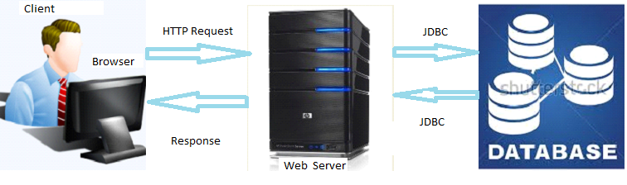

**Figure 4: System architecture diagram**

## Sequence Diagram

A sequence diagram shows object interactions arranged in time sequence, in a Unified Modeling Language (UML) is a kind of interaction diagram that shows how processes operate with one another in a given order. Sequence diagrams typically are associated with use case realizations in the logical view of the system under development.(Merseguer, J. 2002, July)

The symbols below are used in sequence diagram:





: Activation

: Message send

: Message return or 

 : Message call

**Sequence diagram for login to the system**



**Figure 5: Sequence diagram for login to the system**

## Sequence Diagram for Send Request



**Figure 6: Sequence Diagram for Send Request**

## Sequence diagram for Accept request



**Figure 7: Sequence diagram for Accept request**

**Sequence Diagram for Record Visitor**

**Figure 8: Sequence Diagram for Record info**

## Sequence Diagram for Searching Records

## 

**Figure 9: Sequence Diagram for Searching Records**

## Sequence Diagram for View Record

## 

**Figure 10: Sequence Diagram for View Record**

## 

## Sequence Diagram for Update Records



**Figure 11: Sequence Diagram for Update Records**

Sequence Diagram for Viewing Report



**Figure 12:** Sequence Diagram for Viewing Report

**Sequence Diagram for creating new site**



**Figure 13: Sequence Diagram for creating new site**

**Detailed design**

Database design illustrates a detailed data model of a database. It shows how the database is structured and used. Database designs also include Entity-Relationship(ER) database is structures and usedDatabases in an efficient way.

## Database Design

## Notations and their usage

This is an overview of the entire database Design Notations that we will use when drawing Database Model Diagrams and entities relationship diagrams.

**Table**: Object in database design is used to represent things in real world.

**Entity**: In entity Relationship model, an entity notation is a thing of real world which can be distinguished from other aspects of real world. An entity may be a physical object such as a house

**Key Attribute**: A key attribute is the unique characteristic of the entity Relationship: Relationships in Entity Relationship Models show how two entities share information in the database structure.

## Database Schema diagram

By Smith, H. C. (1985), A database schema of a database system is its structure described in a formal language supported by the database management system (DBMS) and refers to the organization of data to create a blueprint of how a database will be constructed (divided into database tables).The formal definition of database schema is a set of formulas (sentences called integrity constraints imposed on a database. These integrity constraints ensure compatibility between parts of the schema.



**Figure 14: Database diagram**

## CHAPTER 4

## IMPLEMENTATION AND TESTING OF THE NEW SYSTEM

## Introduction

The purpose of what done in this whole project is the implementation of the new system which will solve the challenges encountered in CNLG with its existing system.

In this chapter, the analysis done in the third chapter will be used for developing the computerized system, the technologies used in implementation will be described, some of the new system interfaces, and different tests will be done.

## Technologies Used for the System Implementation

To develop this application we have used different technologies and tools namely:

* My SQL: for the creation of the database.
* Netbeans IDE 8.0: for writing and compile codes.
* HyperText MarkupLanguage (HTML), JavaScript andCascading Style Sheet (CSS): for the conception of the graphic interface creation and allowing the users to interact with the system and to control the look and provide efficiency to our web application.
* Java Server Page (JSP).
* Struts2 Framework.
* iText: for the generation of the reports.

**My SQL**: is a collection of data treated as a unit. The purpose of a database is to store and retrieve related information.

**Netbeans IDE 8.0**:

By Jackson, W. (2014), Aprogramming tool or software development tool is a program or application that software developers use to create, debug, maintain, or otherwise support other programs and applications.

NetBeans IDE is a software development tool which is an open-source integrated development environment which supports development of all Java application types (Desktop Application, web application, Applets, etc).

To generate user interfaces we have used Java Server Pages technology which enables Web developers and designers to rapidly develop and easily maintain, information-rich, dynamic Web pages that leverage existing business systems. As part of the Java technology family, JSP technology enables rapid development of Web-based applications that are platform independent. JSP technology separates the user interface from content generation, enabling designers to change the overall page layout without altering the underlying dynamic content.

Struts is an open source framework which makes building web applications easier, based on Java Servlets and JSP technologies.

The Struts framework was created by Craig R. McClanahan and was donated to the Apache software foundation in 2000.

Struts 2 framework implements the Model-View-Controller (MVC) design pattern.In Struts 2 the model, view and controller are implemented by the action, result and FilterDispatcherrespectively.

FilterDispatcher does the job of Controller to map the user to the appropriate action, Model contains the data and the business logic and it helps in implementing the action component from the user. The view is the presentation component of the MVC Pattern, and is commonly implemented using JSP, velocity Template,Free maker or some other presentation-layer technology.

## Cascading style sheets

Cascading style sheets are used to format the layout of Web pages. They can be used to define text styles, table sizes, and other aspects of Web pages that previously could only be defined in a page's HTML.

CSS makes it easy to change styles across several pages at once. For example, a Web developer may want to increase the default text size from 10pt to 12pt for fifty pages of a Web site. If the pages all reference the same style sheet, the text size only needs to be changed on the style sheet and all the pages will show the larger text.

## JSP Technology

JSP technology uses XML-like tags that encapsulate the logic that generates the content for the page. The application logic can reside in server-based resources (such as [JavaBeans component architecture](http://www.oracle.com/technetwork/java/javase/tech/index-jsp-138795.html)) that the page accesses with these tags. Any and all formatting (HTML or XML) tags are passed directly back to the response page. By separating the page logic from its design and display and supporting a reusable component-based design, JSP technology makes it faster and easier than ever to build Web-based applications.

Java Server Pages technology is an extension of the [Java Servlet technology](http://www.oracle.com/technetwork/java/index-jsp-135475.html). Servlets are platform-independent, server-side modules that fit seamlessly into a Web server framework and can be used to extend the capabilities of a Web server with minimal overhead, maintenance, and support. Unlike other scripting languages, servlets involve no platform-specific consideration or modifications; they are application components that are downloaded, on demand, to the part of the system that needs them. Together,

One of the most time-consuming challenges for developers is to exchange data between incompatible systems over the Internet. XHTML document should follow some rules as given below:

1. Tags and attributes names must be in lowercase
2. "Empty" tags must be properly ended with closing slash
3. Tags with opening tag must have an end tag
4. Attributes must always have a value
5. Attributes values must be quoted
6. Must have a DOCTYPE declaration.

Html, head, title, and body elements must be presenttext ReportsA report is a nicely formatted way of presenting the data that you have entered, reports are all about querying a database and displaying the results in a nice format.ItextReport is an open sourceJavareportingtool that can be used in Java enabled applications, including web applications, to generate dynamic content. It has the ability to deliver rich content in various formats such as PDF, HTML, XML files, or directly on the screen or printer.

Itext Report is a content-rendering library, not a standalone application. It cannot runon its own and must be embedded in another client or server-side Java application. Itext Report is a pure Java library and can be used on any platform that supports Java. Because I text Reportis a library and cannot run on its own, you do not really install it.“Installing” I text Report simply means downloading its JAR file and putting it into the Class path of your application along with the other required JAR files.

Generating reports is a common, if not always glamorous, task for programmers. In the past, report generation has largely been the domain of large commercial products. Today, the open source I text Reports report generating library gives Java developers a viable alternative to commercial software .I text Report provides the necessary features to generate dynamic reports, including data retrieval using JDBC (Java Database Connectivity), as well as support for parameters, expressions, variables, and groups.

## Software Tests of OGMSMS

There is a high probability of human beings to make mistakes and further mistakes lead to introduce defects in the developed software, thus integrating software testing into software development lifecycle leads to produce high quality software. A primary purpose of testing is to detect software failures so that defects may be discovered and corrected. Testing cannot establish that a product functions properly under all conditions but can only establish that it does not function properly under specific conditions.

* **Software Testing objectives**
* To demonstrate to the developer and the system owner that the software meetsitsrequirements.
* A successful test shows that the system operates as intended.
* To discoverfaults or defects in the software whereitsbehavioris incorrect or not in conformancewithitsspecification.
* A successful test isa test thatmakes the system performing correctly and so exposes a defect in the system.
* Tests show the presence not the absence of defects.
* **Software Testing Methodology**

**White-box testing** (also known as clear box testing, transparent box testing and structural testing) is a method of testing software that tests internal structures or workings of an application. In white-box testing an internal perspective of the system, as well as programming skills, are used to design test cases. The tester chooses inputs to exercise paths through the code and determine the appropriate outputs.

While white-box testing can be applied at the unit, integration and system levels of the software testing process, but it is usually done at the unit level. It can test paths within a unit, paths between units during integration, and between subsystems during a systemlevel test. Though this method of test design can uncover many errors or problems, it might not detect unimplemented parts of the specification or missing requirements.

**Black-box testing** is a method of software testing that tests the functionality of an application as opposed to its internal structures or workings. Specific knowledge of the application's code/internal structure and programming knowledge in general is not required. The tester is only aware of what the software is supposed to do, but not how. It uses external descriptions of the software, including specifications, requirements, and designs to derive test cases. These tests can be functional or non-functional, though usually functional. Mainly applicable to lower levels of testing: [Unit Testing](http://softwaretestingfundamentals.com/unit-testing/), [Integration Testing](http://softwaretestingfundamentals.com/integration-testing/).

## Unit software testing

Unit Testingis done at the lowest level. It tests the basic unit of software, which is the smallest testable piece of software, and is often called unit or module.Unit testing, also known as component testing refers to tests that verify the functionality of a specific section of code, usually at the function level. These types of tests are usually written by developers as they work on code (white-box style), to ensure that the specific function is working as expected. Unit testing alone cannot verify the functionality of a piece of software, but rather is used to assure that the building blocks the software uses work independently of each other.In procedural programming a unit may be an individual program, function, procedure, while in object-oriented programming, the smallest unit is a method; which may belong to a base/super class, abstract class.

## Integration Testing

Integration testing works to expose defects in the interfaces and interaction between integrated components (modules). Integration tests are used to demonstrate the proper operation of functional units that make up the assembly of modules. Integration testing is any type of software testing that seeks to verify the interfaces between components against a software design. Normally the former is considered a better practice since it allows interface issues to be localized more quickly and fixed.

In our work, after making various unit tests, we tested the whole project to see if the different parts of the software interact well and allow for the generation of outputs and the achievement of expected results.

## Validation or Acceptance Testing

Acceptance Testingis done when the completed system is handed over from the developers to the customers or users. The purpose of acceptance testing is rather to give confidence that the system is working than to find errors. Testing to verify a product meets customer specified requirements. A customer usually does this type of testing on a product that is developed externally.

**Following are screenshots with description of some main interfaces of “Online Genocide Memorial sites Management System”**

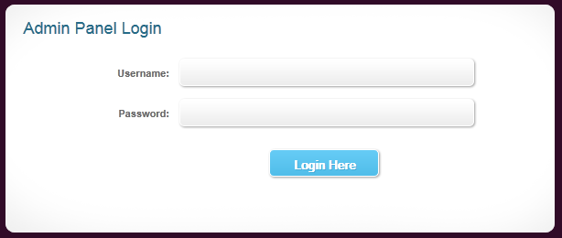

**Figure 15.Loginpage**

This interface allows existing users to identify himself or herself by typing the valid parameters (Username and Password). Once it is validated, the application displays his page depending on the role he/she plays in the system.

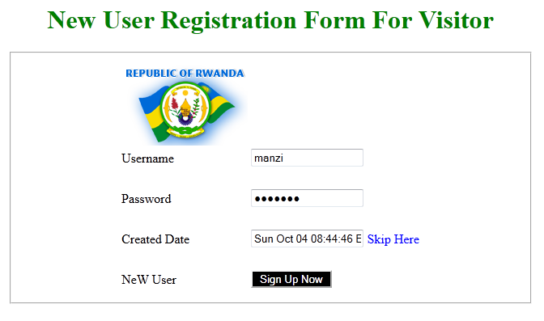

**Figure 16: New users Login page**

This interface allows new users to create by typing (Username and Password). Once it is entered, the application displays his page depending on the role he/she plays in the system.

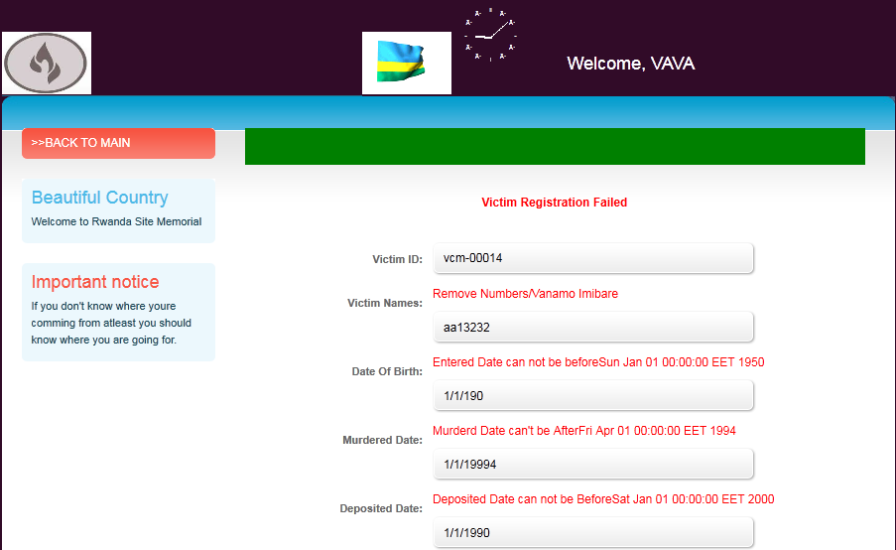

**Figure 17: Victims form**

This interface helps the site managers to record new victims in the grave where is going to be deposited and assign him in a known memorial site

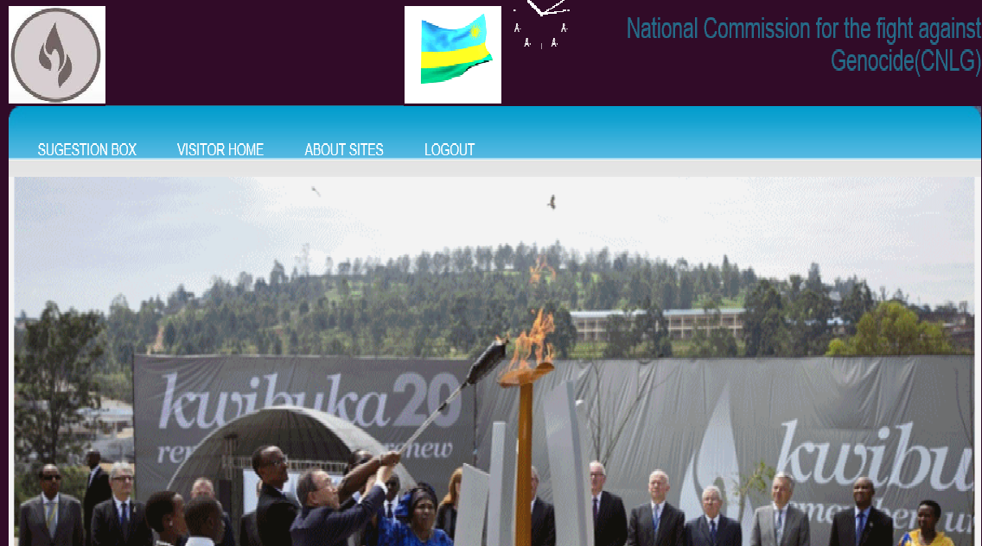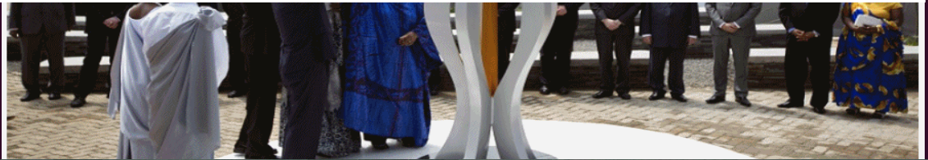

**Figure 18: Visitor welcoming page**

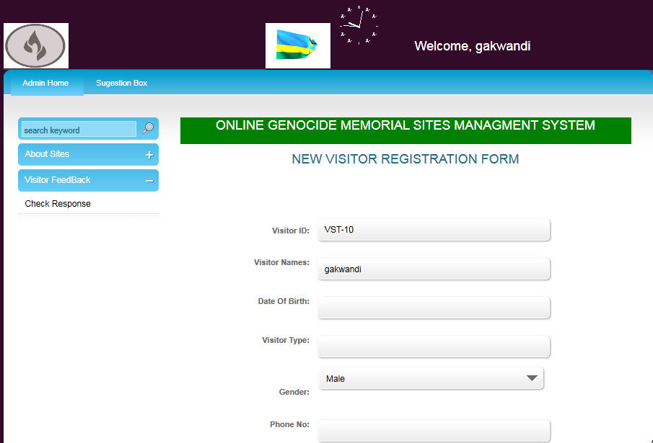

**Figure 19: Visitor Registration form**

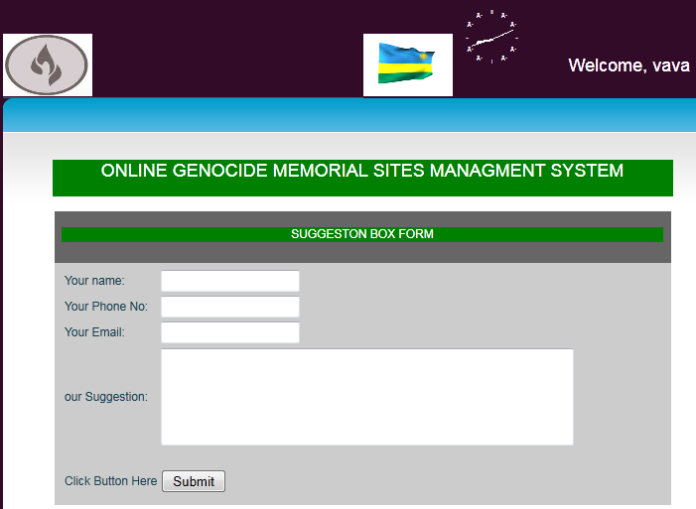

**Figure 20: Suggestion Box form**

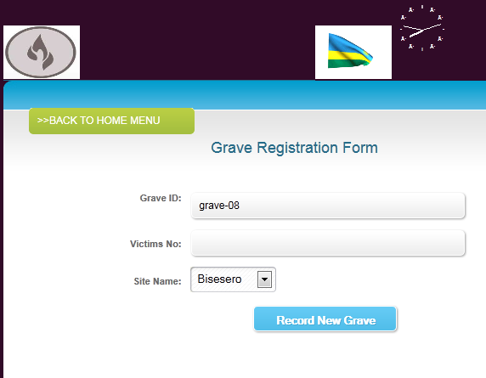

**Figure 21: Grave Registration Form**

## 

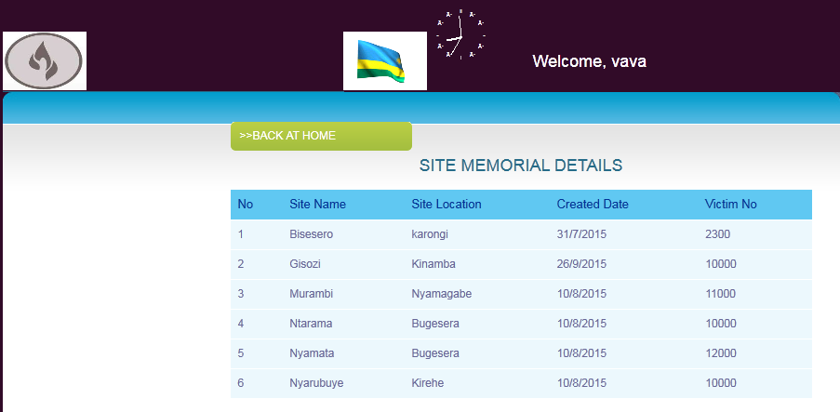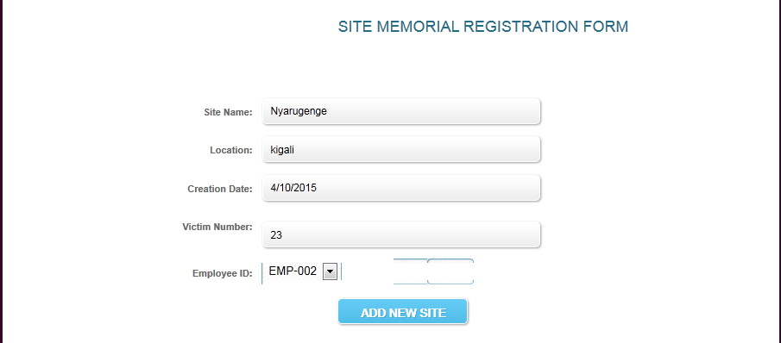

**Figure 22: Form to Add and View Sites**

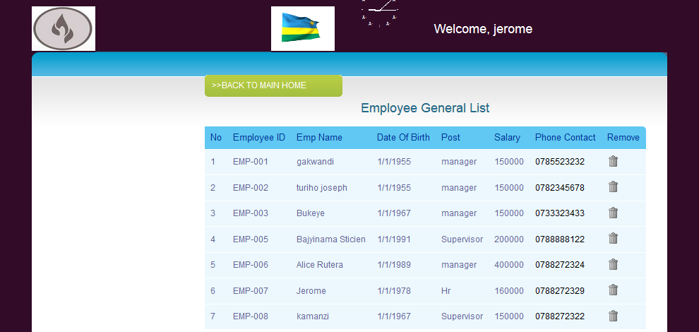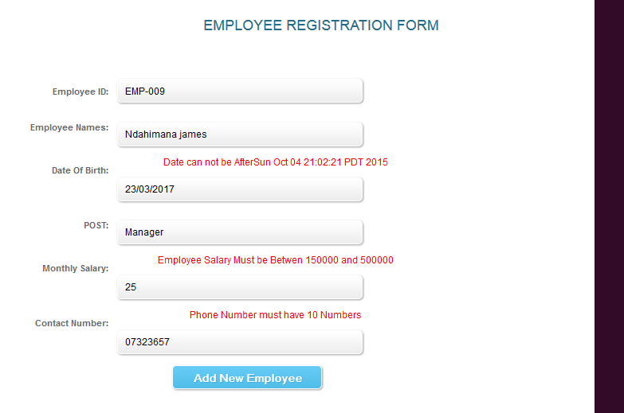

**Figure 23: Form to Add and View Employees**

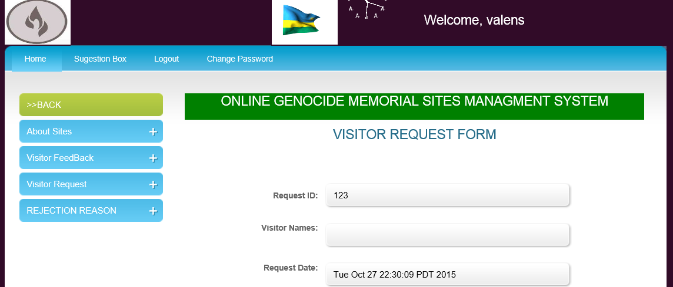

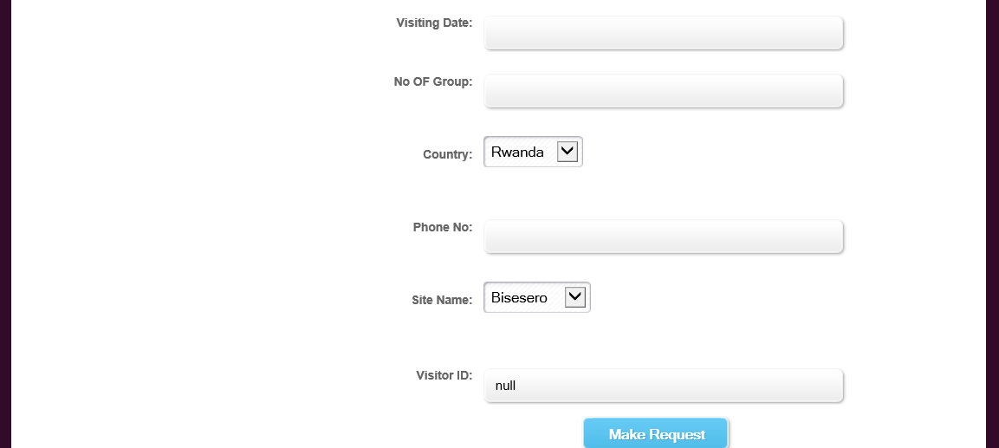

**Figure 24: Form for making a request**

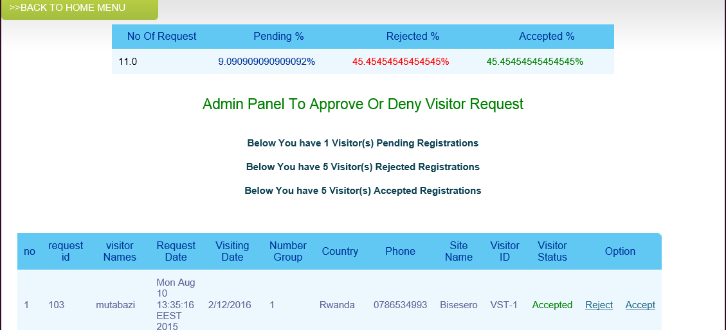

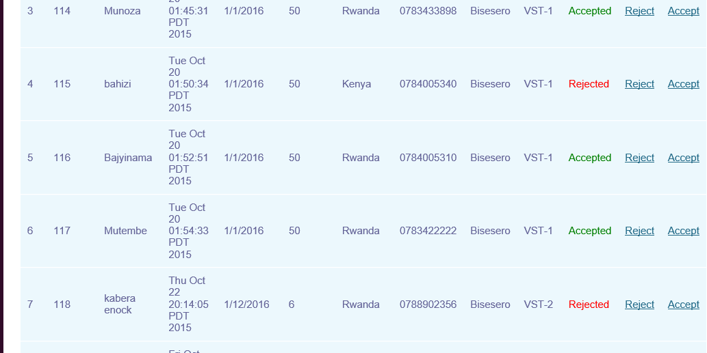

**Figure 25: Form to approve request**

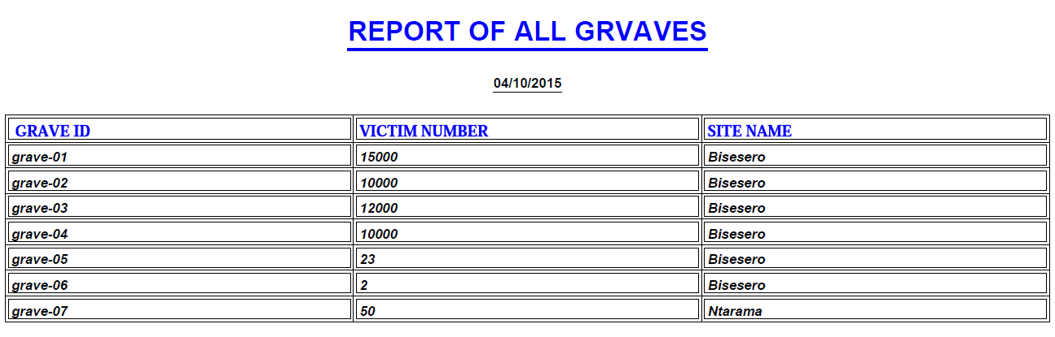

**Figure 26: Grave report form**

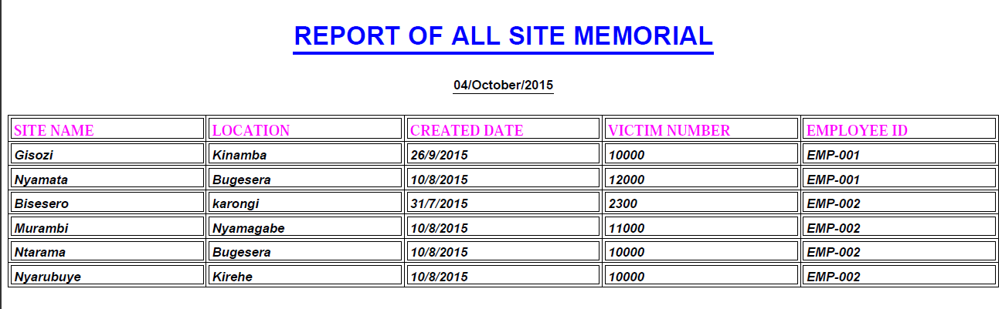

**Figure 27:Sites Memorial Report**

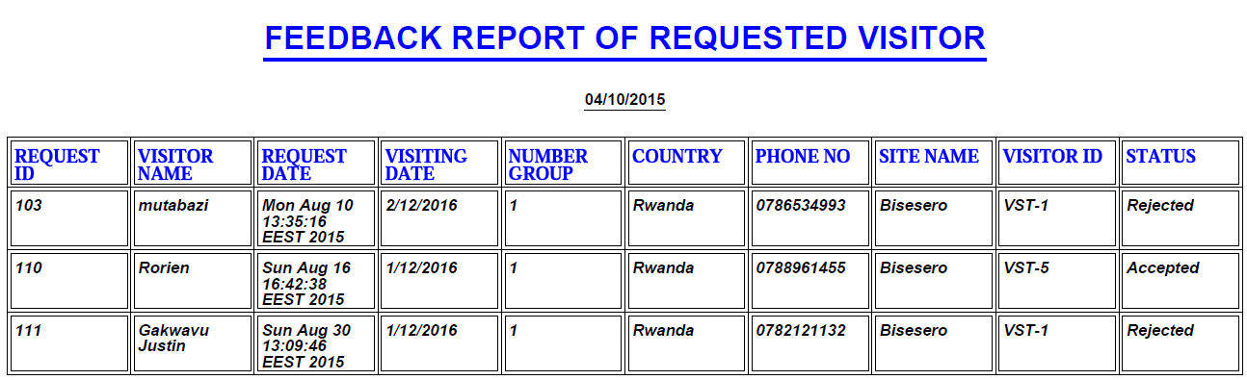

**Figure 28: Feedback Report for visitor request**

**Software deployment Requirements**

For the client machine the minimum specification are:

1. Operating System: Windows(XP,Vista,7,8,or above) ;
2. A Web browser (Mozilla Firefox, Opera, Google Chrome, Internet Explorer, Safari,etc...);
3. LAN connection (intranet) or Internet;
4. RAM: 512 MB.
5. 2 GB or more hard disk free space.

For The server Machine the minimum specification requirements are:

1. Operating System: Windows 2008 Server or above ;
2. Java SE Development Kit;
3. A Web server which support java and JSP (Apache Tomcat, Glassfish);
4. MySQL Database ;
5. RAM: 2GB minimum;
6. 2 GB or more free hard disk space.

# CHAPTER 5

# CONCLUSION AND RECOMMANDATION

# Conclusion

The main objective of the current project was to provide a solution to the problem encountered in CNLG.

When there is no problem, there is no need of solutions, that’s why we have analyzed the existing system and found solutions to the related problems. This project “**online Genocide Memorial Sites management System “** will help to solve the problems found by identifying specific solutions.

Let us list a couple of advantages brought by this system.

* Establishing a connection between headquarter and sites using this system named “Online Genocide Memorial Sites Management System”
* Reporting and management of sites memorial given to the CNLG
* Provide access to the CNLG’s activities and decision making with necessary rights to Managers of the sites and all information related to memorial sites report.
* Help the organization and visitors to minimize the expenses these are using in transport and to know the information of activities on the sites without spending more time.
* Help the sites managers to do the accurate reports.

Different methods such as observation, interview and documentation were used in order to get the problems view within the existing system. After getting the problems in our scope, analysis was done, using UML in order to find the adequate solution by developing the new system using Java programming language. Different tests were done to make sure if the developed system solves the problems encountered in CNLG existing system, we found that results were positive. Our hope is that this software can enable CNLG to improve its performance in all activities management regarding CNLG staff and managers of the sites, and we hope that the use of this software will enhance the operation of all users.

# Recommendation

We would recommend this application to the CNLG staff which will be useful to accomplish their duties easily and to avoid the weaknesses of the existing system because it has been well tested. And perform a periodic back up of data once installed andused, it will be extremely important to avoid potential data loss.

It is worth noting that there are still some areas of improvement, which provides an opportunity for further research.

We finish our work by welcoming and encourage whoever wants to contribute to the improvement of this work, As technology grow day by day I would like to suggest any interested person to add other functions to improve my work in order to improve the Online Genocide Memorial Sites Management System.

## REFERENCES

By Shlaer, S.(1989

## Books and Publications

AUCA Research and publication committee.(2012). Research Manual.

MINANI Jean Baptiste, (2014). Methodology of conception of the information systems.

## Electronic References

Barrett, S., Higgins, C., Twomey, C., & Evans, M. (2006).*U.S. Patent No. 7,000,219*. Washington, DC: U.S. Patent and Trademark Office.

Bernardi, S., Donatelli, S., &Merseguer, J. (2002, July). From UML sequence diagrams and statecharts to analysable petri net models. In Proceedings of the 3rd international workshop on

Binder, R. (2000).*Testing object-oriented systems: models, patterns, and tools*. Addison-Wesley Professional.

,,,,Booch, G. (1986). Object-oriented development. Software Engineering, IEEE Transactions on, (2), 211-221.

…Booch, G., Rumbaugh, J., & Jacobson, I. (1998).Unified Modeling Language (UML). World Wide Web: http://www. rational. com/uml.

Choquier, P., Peyroux, J. F., & Griffin, W. J. (1998). U.S. Patent No. 5,774,668. Washington,

Chow, S., Eisen, P., Johnson, H., & Van Oorschot, P. C. (2003, January).White-box cryptography and an AES implementation.In *Selected Areas in Cryptography* (pp. 250-270).Springer Berlin Heidelberg.

DC: U.S. Patent and Trademark Office.

Eisenkraft, A. (2003). Expanding the 5E model.*SCIENCE TEACHER-WASHINGTON-*, *70*(6), 56-59.

Genero, M., Piattini, M., Manso, E., &Cantone, G. (2003, September). Building UML class diagram maintainability prediction models based on early metrics. In *Software Metrics Symposium, 2003.Proceedings. Ninth International* (pp. 263-275). IEEE.

Gomaa, H. (2005). Designing software product lines with UML (pp. 160-216).IEEE.

Guéhéneuc, Y. G., &Albin-Amiot, H. (2004, October). Recovering binary class relationships:

Jackson, W. (2014).Setting Up Your Java 8 IDE: An Introduction to NetBeans 8.0. In Beginning

Jacobson, I., Booch, G., &Rumbaugh, J. (1999).The unified process.*IEEE Software*, (3), 96-102.

Java 8 Games Development (pp. 19-41). Apress.

Kram, K. E. (1988). *Mentoring at work: Developmental relationships in organizational life*.University Press of America.

Luján-Mora, S., Vassiliadis, P., & Trujillo, J. (2004). Data mapping diagrams for data warehouse design with UML. In Conceptual Modeling–ER 2004 (pp. 191-204).Springer Berlin Heidelberg.

Mellor, S. S. S. J., &Shlaer, S. (1989). *Object-oriented systems analysis: modeling the world in data*. Yourdon.

Montgomery, D. C., & Montgomery, D. C. (1984). *Design and analysis of experiments* (Vol. 7). New York: Wiley.

Putting icing on the UML cake.In ACM SIGPLAN Notices (Vol. 39, No. 10, pp. 301-314).ACM.

Smith, H. C. (1985). Database design: composing fully normalized tables from a rigorous dependency diagram. *Communications of the ACM*, *28*(8), 826-838.

Smith, K. W., Feldman, H. A., &McKinlay, J. B. (2000).Construction and field validation of a self‐administered screener for testosterone deficiency (hypogonadism) in ageing men.*Clinical endocrinology*, *53*(6), 703-711.

Smith, K. W., Feldman, H. A., &McKinlay, J. B. (2000).Construction and field validation of a self‐administered screener for testosterone deficiency (hypogonadism) in ageing men.*Clinical endocrinology*, *53*(6), 703-711.

Software and performance (pp. 35-45).ACM.

Suzuki, J., & Yamamoto, Y. (1999, June).Extending UML with aspects: Aspect support in the design phase.In ECOOP Workshops (Vol. 1743, pp. 299-300).

Weitzman, E., & Miles, M. B. (1995). Computer programs for qualitative data analysis: A software sourcebook. Sage Publications.

Yerkes, R. F., McCulloh, T. H., Schoellhamer, J. E., &Vedder, J. G. (1965). Geology of the Los Angeles basin, California: an introduction. *US, Geol. Surv., Prof. Pap.;(United States)*, *420*.

http://www.w3schools.com/jquery/jquery asp (visited 30/07/2015)

# APPENDICES

## PROPOSAL APPROVAL

## PERMISSION TO COLLECT DATA

# CURRICULUM VITAE